**28**

**Magnetic Fields**

|  |
| --- |
| **CHAPTER OUTLINE** |

28.1 Analysis Model: Particle in a Field (Magnetic)

28.2 Motion of a Charged Particle in a Uniform Magnetic Field

28.3 Applications Involving Charged Particles Moving in a Magnetic Field

28.4 Magnetic Force Acting on a Current-Carrying Conductor

28.5 Torque on a Current Loop in a Uniform Magnetic Field

28.6 The Hall Effect

* An asterisk indicates a question or problem new to this edition.

|  |
| --- |
| **ANSWERS TO THINK – PAIR – SHARE PROBLEMS** |

**\*TP28.1 Conceptualize** When the current is turned on, there will be a torque on the loop causing it to rotate clockwise. As it rotates clockwise the spring stretches, exerting a counter-torque. At a certain equilibrium angle ** the torque due to the magnetic force balances the counter torque due to the spring.

**Categorize** We model the loop as a rigid object in equilibrium.

**Analyze** Write a rigid object in equilibrium equation:

 (1)

Substitute for the individual torques, assuming that the spring force is straight downward:

 (2)

From the geometry shown in Figure ANS. TP28.1, we see that the extension *x* of the spring is

 (3)

Substitute Equation (3) into Equation (2) and solve for *k*:



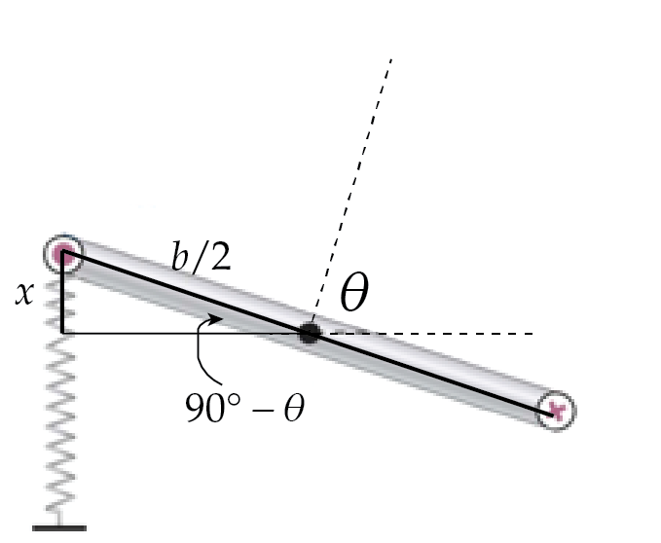

Fig.ANS TP28.1

**Finalize** Test to see if the spring constant *k* behaves appropriately as the variables change: Let *I*, *a*, and *B* increase. Let *b* increase. Let ** go to 90°. You should be able to argue that the resulting change in *k* is reasonable conceptually.

*Answer:* 

**\*TP28.2 Conceptualize** Read the material in Section 28.6 carefully to understand the Hall effect.

**Categorize** This problem is specifically aimed at the Hall effect material in Section 28.6.

**Analyze** According to Equation 28.23, we expect a graph of the Hall voltage against the magnetic field to be linear. The graph for the data supplied looks like the following:

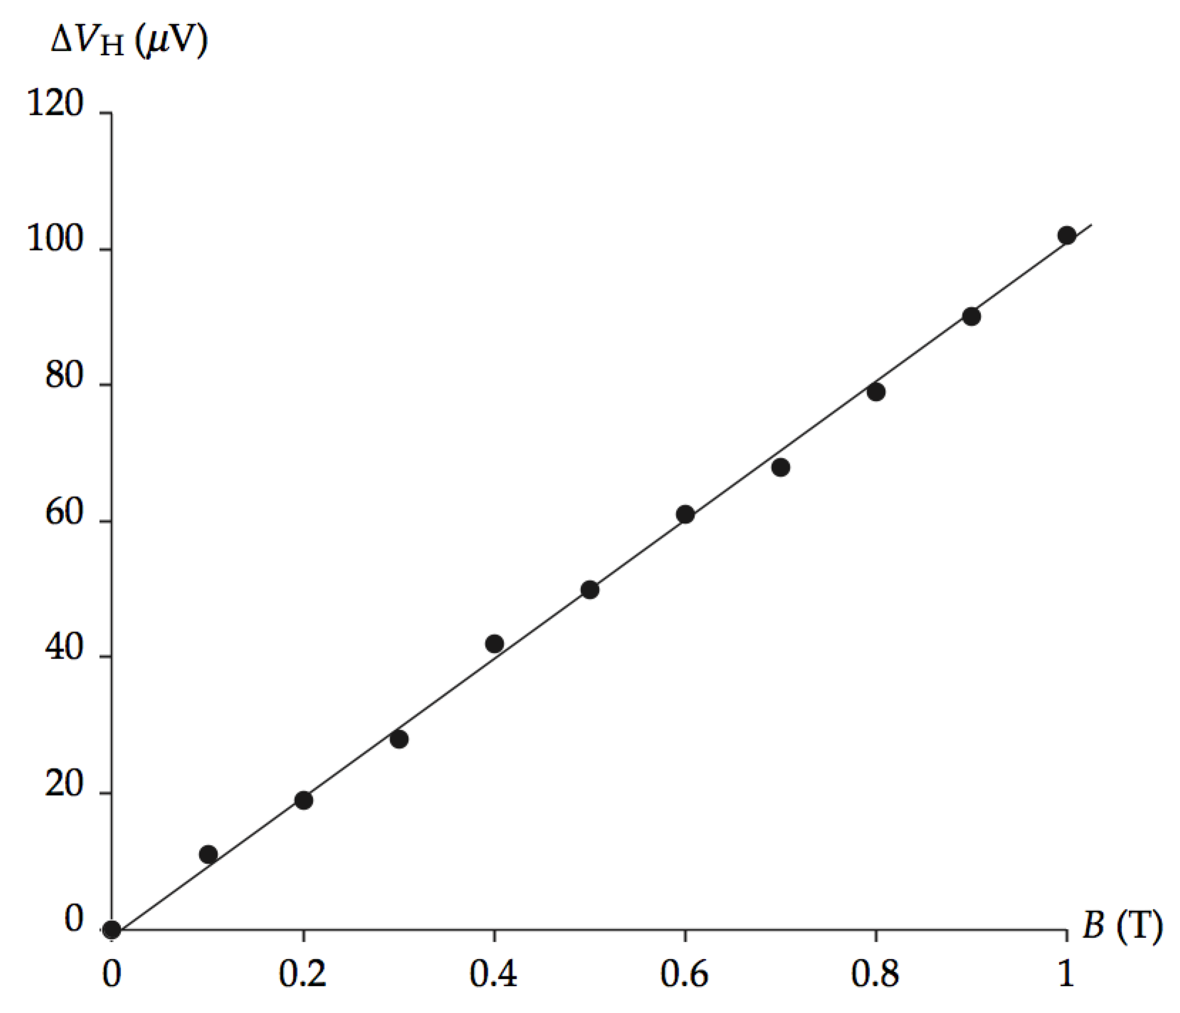

The slope of the best-fit line for these data is



Based on Equation 28.23, this slope should be equal to . Set the slope equal to this quantity and solve for the thickness *t* of the sample:



Substitute numerical values:



**Finalize** Notice that there is some scatter in the data points, so there will be some uncertainty in the thickness *t*.

*Answer:* 0.125 mm

|  |
| --- |
| **SOLUTIONS TO END-OF-CHAPTER PROBLEMS** |

Section 28.1 Analysis Model: Particle in a Field (Magnetic)

**P28.1** Gravitational force:



Electric force:



Magnetic force:



**P28.2** At the equator, the Earth’s magnetic field is horizontally   
north. Because an electron has   
negative charge,  is   
opposite in direction to    
Figures are drawn looking down.

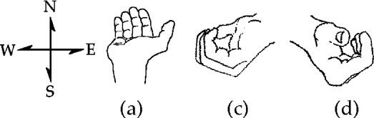

**ANS. FIG. P28.2**

(a) Down × North = East, so the force is directed 

(b) North × North = sin 0° = 0: 

(c) West × North = Down, so the force is directed 

(d) Southeast × North = Up, so the force is 

**P28.3** To find the direction of the magnetic field, we use ****. Since the particle is positively charged, we can use the right hand rule. In this case, we start with the fingers of the right hand in the direction of and the thumb pointing in the direction of . As we start closing the hand, our fingers point in the direction of  after they have moved 90°. The results are

(a)  (b)    
(c) 

**P28.4** The magnitude of the force on a moving charge in a magnetic field is   
 so





**P28.5** (a) The magnetic force is given by



(b) From Newton’s second law,



**P28.6** (a) The proton experiences maximum force when it moves perpendicular to the magnetic field, and the magnitude of this maximum force is



(b) From Newton’s second law,



(c) Since the magnitude of the charge of an electron is the same as that of a proton, a force would be exerted on the electron that had the same magnitude as the force on a proton, but in the opposite direction because of its negative charge.

(d) 

**P28.7** 

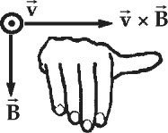

**ANS. FIG. P28.7**



From ANS. FIG. P28.7, the right-hand rule shows that B must be in the –*y* direction to yield a force in the +*x* direction when *v* is in the *z* direction. Therefore,



**Section 28.2 Motion of a Charged Particle in a Uniform Magnetic Field**

**P28.8** Find the initial horizontal velocity component of an electron in the beam:





Gravitational deflection: The electron’s horizontal component of velocity does not change, so its time of flight to the screen is



Its vertical deflection is downward:



which is unobservably small.

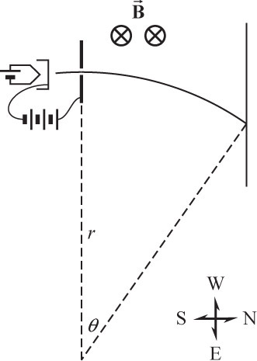

**ANS. FIG. P28.8 (a)**

(a) 

(b) 

Magnetic deflection: Use the cross product to find the initial direction of the magnetic force on an electron:

velocity (north) × magnetic field (down) = –west = east.

Because the direction of the magnetic force direction is always perpendicular to the velocity, the electron is deflected so that it curves toward the east in a circular path with radius *r*—see ANS. Fig. 28.8 (a):



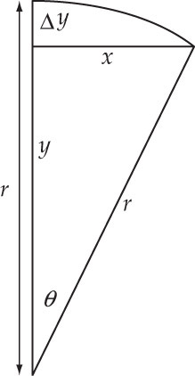

**ANS. FIG. P28.8 (b)**

The path of the beam to the screen   
subtends at the center of curvature an   
angle *θ*, as shown in ANS. Fig. 28.8(b):



The deflection to the east is



(c) 

(d) 

The speed of an electron in the beam remains constant, but its velocity direction changes as it travels along the path, and the force direction changes because it is always perpendicular to the velocity; therefore an electron does not move as a projectile with constant vector acceleration perpendicular to a constant northward component of velocity.

(e) 

However, an electron’s northward velocity component stays nearly constant, changing from *vx* = *v* to *vx* = *v* cos 2.38°. The relative change is



that is,

(f) 

**P28.9** An electric field changes the speed of each particle according to   
(K + U)i = (K + U)f. Therefore, noting that the particles start from rest, we can write



After they are fired, the particles have the magnetic field change their direction as described by 



For the protons, 

(a) For the deuterons,



(b) For the alpha particles,



**P28.10** (a) We must use a right-handed coordinate system, so treat north as the positive *x* direction, up as the positive *y* direction, and east as the positive *z* direction. The ball’s initial velocity is north, and is given by



and the magnetic field is west,



The trajectory of the ball is that of an object moving under the influence of gravity: projectile motion. The ball’s final velocity is



where *v* = 20.0 m/s, because under gravity, the horizontal component of velocity does not change.

We find the final *y* component of velocity of the ball after it falls a distance *h* and just before it hits the ground:



Substituting and solving,



The force on the ball just before it hits the ground is



(b) We find the time interval the ball takes to reach the ground under the acceleration due to gravity:



We can estimate an extreme upper bound in the change in the ball’s horizontal velocity caused by the magnetic force by assuming the average horizontal component of the force to be half its final maximum horizontal value of 0.990 × 10–6 N. For such an average horizontal component over the entire fall, the change in the horizontal velocity would be less than



Compare this to the initial value of 20.0 m/s:





**P28.11** For each electron,  and 

The electrons have no internal structure to absorb energy, so the collision must be perfectly elastic:





**P28.12** For each electron,  and 

The electrons have no internal structure to absorb energy, so the collision must be perfectly elastic:



**P28.13** (a) We begin with, or *qRB* = *mv.*

But, *L* = *mvR* = *qR*2*B.*

Therefore,



(b) Thus,



**Section 28.3 Applications Involving Charged Particles Moving in a Magnetic Field**

**P28.14** (a) The name “cyclotron frequency” refers to the angular frequency or angular speed



For protons,



(b) The path radius is 

Just before the protons escape, their speed is



**\*P28.15** **Conceptualize** Be sure you understand the material on the cyclotron in Section 28.3. The proton makes many revolutions around the cyclotron, accelerating between the dees twice for each revolution. Notice that the magnetic field does no work; it only causes the circular path of the proton. The work is done by the electric field each time the proton crosses the gap between the dees. That work is independent of the speed of the proton and depends only on charge and voltage as described in Equation 24.4.

**Categorize** A proton in the cyclotron can be modeled as a *nonisolated system* for *energy*.

**Analyze** Write the appropriate reduction of Equation 8.2 for a proton in a cyclotron:

 (1)

In this equation, the net work*W* done on the proton is the sum of the individual values of work done for each acceleration between the dees:

 (2)

where *N* is the total number of revolutions around the cyclotron and *W*1 is the work done on the proton during any *one* acceleration between the dees. The factor of 2 indicates that there are two such accelerations for each revolution of the proton. Solve Equation (2) for *N* and substitute for *W*1 from Equation 24.4:

 (3)

Substitute numerical values:



**Finalize** Sometimes problems are easier than they look! It may have seemed hopeless to find the answer to this problem when we knew so little information. In fact, we only needed two of the three pieces of information that were provided! What if the patient had asked, “How long does it take in time for a proton to accelerate to its final energy?” You were lucky she asked the question she did. This latter question cannot be answered without knowing the magnetic field of the cyclotron, as we see from Equation 28.5.]

*Answer:* 1.56 ×105

**P28.16** We first determine the velocity of the particles from



so 

Then, from



we solve for the radius:



(a) Substituting numerical values for uranium-238,



(b) For uranium-235 ions,



(c) 

(d) 

(e) 

**P28.17** Note that the “cyclotron frequency” is an angular speed. The motion of the proton is described by





(a) 

(b) 

(c) 

(d) The kinetic energy of the proton changes by ∆*K* = *e*∆*V* = *e*(600 V) = 600 eV twice during each revolution, so the number of revolutions is



(e) From 



**P28.18** (a) The path radius is *r* = *mv*/*qB*, which we can write in terms of the (kinetic) energy *E* of the particle:



so 

Differentiating, we get,



From the relation *r* = *mv*/*qB*, we have *v* = *qBr*/*m*, which we substitute:



From the relation for the particle’s average rate of increase in energy (given in the problem), we have



(b) 

(c) 

(d) We use the approximation



**P28.19** (a) 

(b) 

(c) 

(d) With kinetic energy 100 eV, an electron has speed given by



from which we obtain



The time interval to travel 40.0 cm is



If it is fired horizontally it will fall vertically by



an immeasurably small amount. An electron with higher energy falls by a smaller amount.



**Section 28.4 Magnetic Force Acting on a Current-Carrying Conductor**

**P28.20** (a) The magnitude of the magnetic force is given by



(b) Neither the direction of the magnetic field nor that of the current is given. Both must be known in order to determine the direction of the magnetic force. In this problem, you can only say that the force is perpendicular to both the wire and the field.

**P28.21** The vector magnetic force on the wire is



**P28.22** At all points on the wire, the magnetic force is upward and the gravitational force is downward. For the entire length *L* of the wire, apply the particle in equilibrium model, assuming that the wire is levitated as claimed, and then solve for the required magnetic field *B*:



Express the mass of the wire in terms of the density of copper and its volume and the current in terms of the power delivered to the wire of resistance *R*:



Substitute for the volume of the wire and its resistance in terms of its length *L* and area *A*:



where *ρ* is the resistivity of copper. Express the length *L* of the wire in terms of the radius of the Earth and the area *A* of the wire in terms of its radius:



Substitute numerical values:



This field magnitude is far larger than that of the Earth, which is about 30 *µ*T at the equator. Therefore, this wire could not be levitated in the Earth’s magnetic field as described.

**P28.23** Refer to ANS. FIG. P28.23. The rod feels force

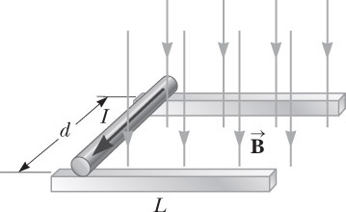

**ANS. FIG. P28.23**



From the work-energy theorem, we have





or 

and 



**P28.24** Refer to ANS. FIG. P28.23 above. The rod feels force



From the work-energy theorem, we have



Solving for the velocity gives



**P28.25** (a) The magnetic force must be upward to lift the wire. For current in the south direction, the magnetic field must be  to produce an upward force, as shown by the right-hand rule in the figure.

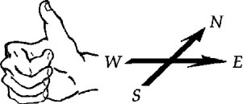

**ANS. FIG. P28.25**

(b)  with FB = Fg = *mg*

 so 



**P28.26** (a) 

(b) 

(c) The minimum magnetic filed would be perpendicular to the current in the wire so that the magnetic force is a maximum. For the magnetic force to be directed upward when the current is toward the left,  must be directed out of the page. Then,



from which we obtain



(d) If the field exceeds 0.200 T, the upward magnetic force exceeds the downward gravitational force, so the wire accelerates upward.

**P28.27** (a) Refer to ANS. FIG. P28.27. The magnetic field is perpendicular to all line elements  on the ring, so the magnetic force  on each element has magnitude  and is radially inward and upward, at angle *θ* above the radial line. The radially inward components *IdsB* cos*θ* tend to squeeze the ring but all cancel out because forces on opposite sides of the ring cancel in pairs. The upward components *IdsB* sin*θ* all add to .

(a) magnitude: 

(b) direction: 

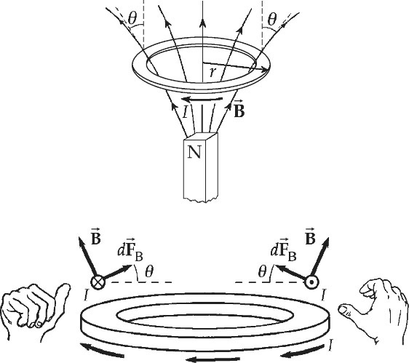

**ANS. FIG. P28.27**

**P28.28** For each segment, *I* = 5.00 A and 

|  |  |  |  |
| --- | --- | --- | --- |
|  | Segment |  |  |
| (a) | *ab* |  |  |
| (b) | *bc* |  |  |
| (c) | *cd* |  |  |
| (d) | *da* |  |  |

(e) 

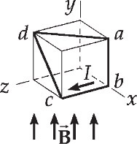

**ANS. FIG. P28.28**

**Section 28.5 Torque on a Current Loop in a Uniform Magnetic Field**

**P28.29** (a) The field exerts torque on the needle tending to align it with the field, so the minimum energy orientation of the needle is:



where its energy is



(b) It has maximum energy when pointing in the opposite direction, 

where its energy is



(c) From , we have



**P28.30** The torque on a current loop in a magnetic field is , and maximum torque occurs when the field is directed parallel to the plane of the loop (*θ* = 90°). Thus,



**\*P28.31 Conceptualize** Normally, a sphere placed on an inclined plane will roll downhill due to gravity. There must be some additional magnetic force or torque on the sphere that is counteracting the gravitational force.

**Categorize** The sphere remains at rest. Therefore, it is modeled as both a *particle in equilibrium* and a *rigid object in equilibrium.*

**Analyze** Redraw the diagram with forces added in preparation for applying the particle in equilibrium model. Recall that there is no magnetic force on a closed loop of current:

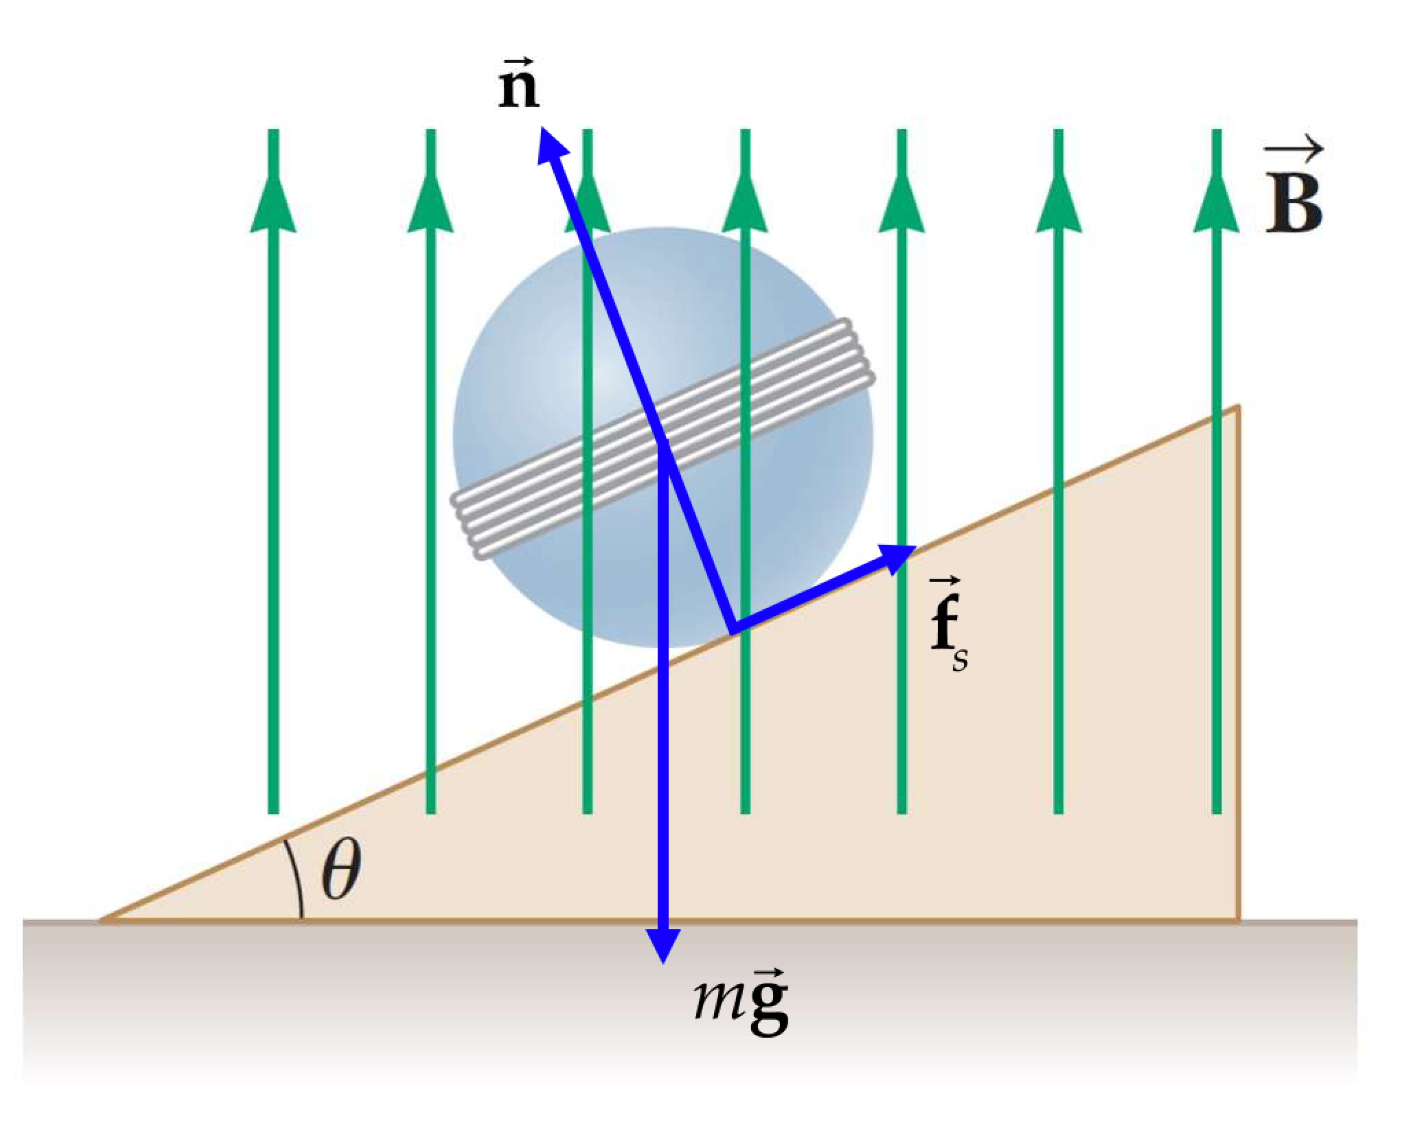

Redraw the figure again with details added that will be necessary to determine the torques on the sphere about its center, in preparation for applying the rigid object in equilibrium model:

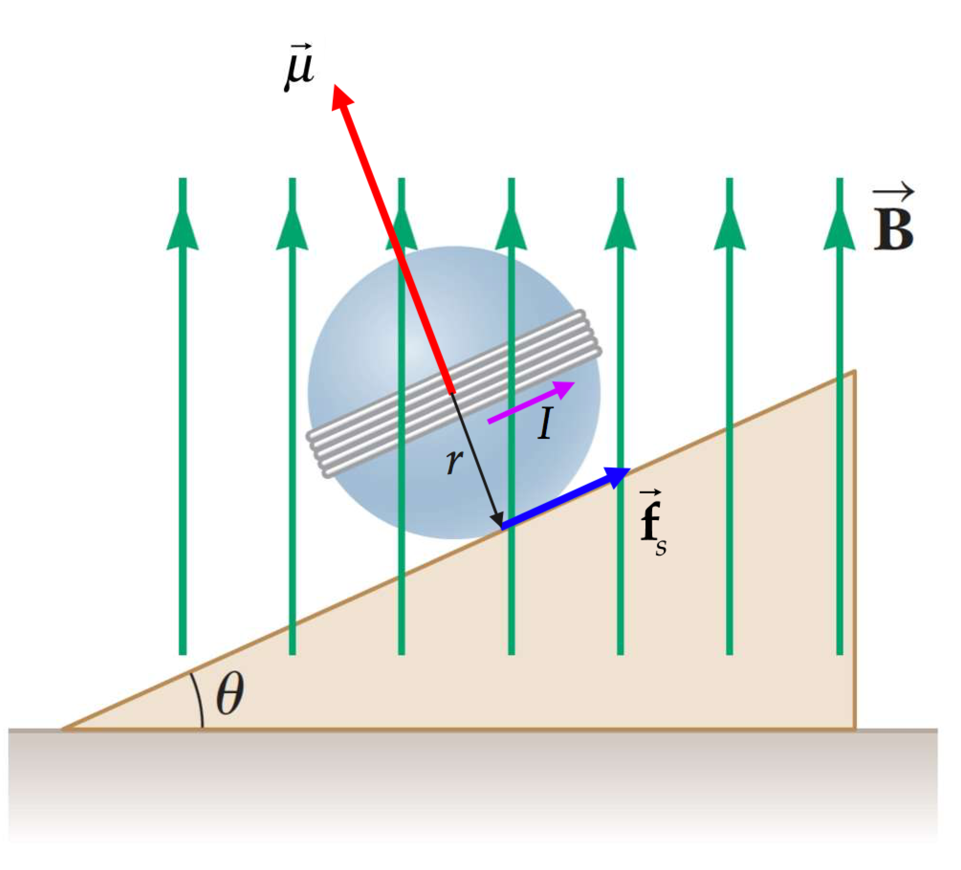

(a) Write a force equilibrium equation from the particle in equilibrium model for the direction parallel to the plane in the force diagram:

 (1)

If we take torques on the sphere about its center, there are only two torques—one from the friction force, as shown in the torque diagram, and the other from the magnetic torque on the current loop—trying to align the magnetic moment of the loop with the magnetic field. Write a torque equilibrium equation from the rigid body in equilibrium model:

 (2)

The magnetic moment of the current loops can be evaluated from Equation 28.17:

 (3)

Divide Equation (2) by Equation (1), substitute Equation (3), and solve for the current *I*:

(4)

Substitute numerical values:



This current must be counterclockwise when looking down on the sphere from above so as to give the direction of the magnetic moment shown in the torque diagram.

(b) The current in Equation (4) is independent of the angle **! Therefore, you cannot reduce the current by lowering the plane. Equations (1) and (2) show that both the frictional torque and the magnetic torque are proportional to sin **, so as one changes, the other changes in the same way.

**Finalize** One question that wasn’t asked is this: Is this trick possible in practice? The magnetic field of 0.350 T is large, but attainable with a strong electromagnet. The current of 0.713 A is also large, but also attainable. But can you create this field and this current without the magnet being visible and without the required wires connected to the coil being visible? So the answer is not clear. Perhaps you can hide batteries in the sphere to provide the current. Be careful: the weight distribution of the batteries will create a gravitational torque of their own! Perhaps you can hide the electromagnetic inside the inclined plane. Be careful: be sure to hide the electrical cord from the wall!]

*Answer:* (a) 0.713 A (b) Current is independent of angle.

**\*P28.32** **Conceptualize** Be sure you are clear on what is happening. At the beginning, the picture appears in its normal orientation, hanging on the wall, as in part (a) of Figure P28.32. When the magnetic field is applied, the magnetic torque on the wire surrounding the picture causes the picture to rotate about its upper edge and stand out from the wall as in part (b). Consult Example 28.5 for a similar situation, with the magnetic field directed vertically upward.

**Categorize** We model the picture as a *rigid object in equilibrium*.

**Analyze** (a) Let us imagine that the picture is in its final orientation, with its face perpendicular to the wall. There are two torques on the picture: magnetic and gravitational. Set up the torque equilibrium equation from the rigid object in equilibrium model:

 (1)

Substitute for the torques, using Equation 28.18 for the magnetic torque for the final orientation of the picture, and solve for the magnetic field *B*:



Substitute numerical values:



(b)This is a relatively strong magnetic field, on the order of 104 times that at the surface of the Earth. If you set the effect up this way, you will need to take special precautions against actors carrying metal objects into the scene. Those objects may become projectiles as they experience strong magnetic forces. In addition, be sure that no actors have pacemakers or other medical devices that could be affected by a strong magnetic field.

**Finalize** You could reduce the dangerous magnitude of the required magnetic field by increasing the number *N* of turns of wire on the picture. You could also reduce the field by increasing the width *w* of the picture. Increasing the current would help, but this may be restricted by the size of the wire you are using. Notice that increasing the angle ** decreases the required magnetic field, so that would also be a consideration in reducing the danger. Notice that if **→ 0, the magnetic field becomes infinite: it is not possible to make the pictures stick straight out from the wall with a vertical magnetic field.]

*Answer:* (a) 0.519 T (b) The magnetic field is dangerous; it is on the order of 104 times that at the surface of the Earth.

**P28.33** (a) 



(b) Note that *φ* is the angle between the magnetic moment and the  field. The loop will rotate so as to align the magnetic moment with the  field, clockwise as seen looking down from a position on the positive *y* axis.

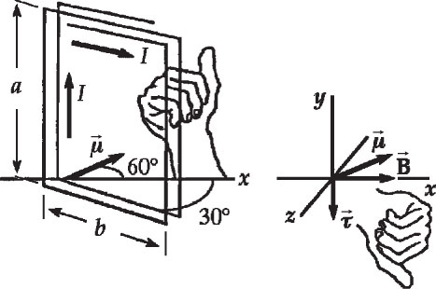

**ANS. FIG. P28.33**

**P28.34** (a) The current in segment *ab* is in the +*y*   
direction. Thus, by the right-hand rule, the   
magnetic force on it is in the 

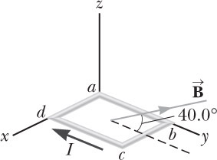

**ANS. FIG. P28.34**

(b) Imagine the force on segment *ab* being   
concentrated at its center. Then, with a   
pivot at point *a* (a point on the *x* axis), this force would tend to rotate segment *ab* in a clockwise direction about the *z* axis, so the direction of this 

(c) The current in segment *cd* is in the –*y* direction, and the right-hand rule gives the direction of the magnetic force as the 

(d) With a pivot at point *d* (a point on the *x* axis), the force on segment *cd* (to the left, in –*x* direction) would tend to rotate it counter clockwise about the *z* axis, and the direction of this 

(e) 

(f) 

(g) The magnetic force is perpendicular to both the direction of the current in *bc* (the +*x* direction) and the magnetic field. As given by the right-hand rule, this places it 

(h) The force acting on segment *bc* tends to rotate it counter clockwise about the *x* axis, so the torque is in 

(i)  There is no torque about the *x* axis because the lever arm of the force on segment *ad* is zero.

(j) From the answers to (b), (d), (f), and (h), the loop tends to rotate  about the *x* axis.

(k) 

(l) The magnetic moment vector is perpendicular to the plane of the loop (the *xy* plane), and is therefore parallel to the *z* axis. Because the current flows clockwise around the loop, the magnetic moment vector is directed downward, in the negative *z* direction. This means that the angle between it and the direction of the magnetic field is 

(m) 

**P28.35** (a) From Equation 29.17, , so the maximum magnitude of the torque on the loop is





(b) The potential energy is given by



so 

Now, since



the range of the potential energy is: .

**Section 28.6 The Hall Effect**

**P28.36** (a)  so 

Then, the unknown field is



(b)  so



Additional Problems

**P28.37** From , we have



therefore, the angular frequency for each ion is



and



**P28.38** (a) At the moment shown in Figure 28.7, the particle must be moving upward in order for the magnetic force on it to be 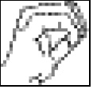 into the page, toward the center of this turn of its spiral path. Throughout its motion it circulates clockwise.

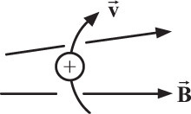

**ANS. FIG. P28.38 (a)**

(b) After the particle has passed the middle of the bottle and moves into the region of increasing magnetic field, the magnetic force on it has a component to the left (as well as a radially inward component) as shown. This force in the –*x* direction slows and reverses the particle’s motion along the axis.

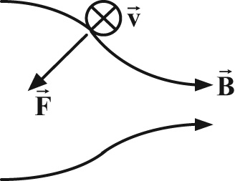

**ANS. FIG. P28.38 (b)**

(c) The magnetic force is perpendicular to the velocity and does no work on the particle. The particle keeps constant kinetic energy. As its axial velocity component decreases, its tangential velocity component increases.

(d) The orbiting particle constitutes a loop of current in the *yz* plane and therefore a magnetic dipole moment  in the –*x* direction. It is like a little bar magnet with its N pole on the left.

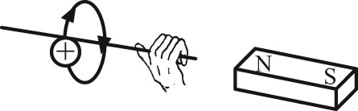

**ANS. FIG. P28.38 (d)**

**P28.39** (a) The particle moves in an arc of a circle with radius



(b) 

**P28.40** (a) Define vector  to have the downward direction of the current, and vector  to be along the pipe into the page as shown. The :

 in the direction of 

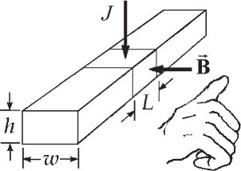

**ANS. FIG. P28.40**

(b) The sodium, consisting of ions and electrons, flows along the pipe transporting no net charge. But inside the section of length *L*, electrons drift upward to constitute downward electric current   
*J* × (area) = *J Lw*.

The current then feels a magnetic force 

This force along the pipe axis will make the fluid move, exerting pressure



(c) 

(d)  and

(e) 

**P28.41** Let vi represent the original speed of the alpha particle. Let  and vp represent the particles’ speeds after the collision. We have conservation of momentum



and the relative velocity equation



Eliminating vi,



For the proton’s motion in the magnetic field,



For the alpha particle,



and the radius of the alpha particle’s trajectory is given by



**P28.42** (a) If , then



Since the force actually experienced is , observe that

, , and .

(b) If , then



(c) If *q* = –*e* and , then

 

Reversing either the velocity or the sign of the charge reverses the force.

**P28.43** (a) The field should be in the +*z*-direction, perpendicular to the final as well as to the initial velocity, and with  as the direction of the initial force.

(b) 

(c) The path is a quarter circle, of length



(d) 

**\*P28.44** **Conceptualize** Based on Section 28.4, we know that there will be a magnetic force on the wire, since it is carrying a current in a magnetic field. Because the current is oscillating, the force on the wire will oscillate at the same frequency, and it becomes a driving force on a vibrating system (the wire acting as a string fixed at both ends), raising the possibility of exciting a resonance response in the system, as discussed in Section 17.5.

**Categorize** We model the wire from which the light fixture hangs as carrying a wave under boundary conditions, leading to the possibility of standing waves.

**Analyze** Use Equation 17.8 to find the fundamental frequency of the wire from which the light fixture hangs:



Substitute numerical values:



The fundamental frequency (and every higher harmonic) of the wire is higher than the 60-Hz frequency at which the current oscillates, so the wire cannot possibly be driven into resonance at 60 Hz by the magnetic force.

**Finalize** You should advise your attorney that the magnetic field of the Earth is not causing the buzzing noise. There is definitely a buzzing noise, so you will need to look elsewhere in the setup of the hanging lamp to determine the source.]

*Answer:* no

**P28.45** Suppose the input power is 120 W = (120 V)*I*, which gives a current of



Also suppose



and the output power is



The torque is then 

Suppose the area is about (3 cm) × (4 cm), or 

Suppose that the field is 

Then, the number of turns in the coil may be found from

:



giving 

The results are:

(a)  (b)  (c)   
(d)  (e) 

**P28.46** The radius of the circular path followed by the particle is



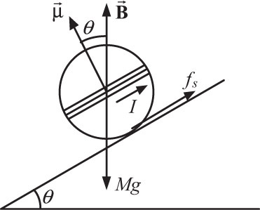

**ANS. FIG. P28.46**

This is exactly equal to the length *h* of the field region. Therefore, the particle will not exit the field at the top, but rather will complete a semicircle in the magnetic field region and will exit at the bottom, traveling in the opposite direction with the same speed.

**P28.47** (a) The magnetic force acting on ions in the blood stream will deflect positive charges toward point *A* and negative charges toward point *B.* This separation of charges produces an electric field directed from *A* toward *B*. At equilibrium, the electric force caused by this field must balance the magnetic force, so



which gives



(b) 

(c) 

**P28.48** (a) The torque on the dipole  has magnitude *µB* sin *θ* ≈ *µBθ*, proportional to the angular displacement if the angle is small. It is a restoring torque, tending to turn the dipole toward its equilibrium orientation. Then the statement that its motion is simple harmonic is true for small angular displacements.

(b) The statement is true only for small angular displacements for which sin *θ* ≈ *θ*.

(c)  becomes



where  is the angular frequency and



is the frequency in hertz.

(d) The equilibrium orientation of the needle shows the direction of the field. In a stronger field, the frequency is higher. The frequency is easy to measure precisely over a wide range of values.

(e) From part (c), we see that the frequency is proportional to the square root of the magnetic field strength:



Therefore,



Challenge Problems

**P28.49**  where the effective current due to the orbiting electrons is  and the period of the motion is .

The electron’s speed in its orbit is found by requiring  or



Substituting this expression for *v* into the equation for *T*, we find



Therefore,



**P28.50** The magnetic force on each proton,  downward and perpendicular to the velocity vector, causes centripetal acceleration, guiding it into a circular path of radius *r*, with

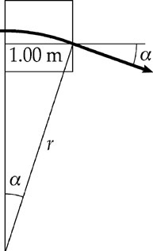

**ANS. FIG. P28.50**



and 

We compute this radius by first finding the proton’s speed from 



Now, 

(a) From ANS. FIG. P28.50 observe that



(b) The magnitude of the proton momentum stays constant, and its final *y* component is



**P28.51** A key to solving this problem is that reducing the normal force will reduce the friction force: *FB* = *BIL* or .

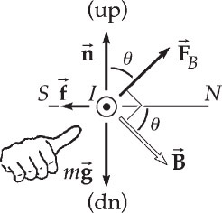

**ANS. FIG. P28.51**

When the wire is just able to move,



so 

and 

Also, 

so :  and 

We minimize *B* by minimizing *FB*:

 

Thus,  for the smallest field, and



The answers are

(a) magnitude:  and

(b) direction: 

|  |
| --- |
| **ANSWERS TO QUICK-QUIZZES** |

1. (e)
2. **(i)** (b) **(ii)** (a)
3. (c)
4. **(i)** (c), (b), (a) **(ii)** (a) = (b) = (c)

|  |
| --- |
| **ANSWERS TO EVEN-NUMBERED PROBLEMS** |

**P28.2** (a) west; (b) zero deflection; (c) up; (d) down

**P28.4** 48.9° or 131°

**P28.6** (a) 1.44 × 10–12 N; (b) 8.62 × 1014 m/s2; (c) A force would be exerted on the electron that had the same magnitude as the force on a proton but in the opposite direction because of its negative charge; (d) The acceleration of the electron would be much greater than that of the proton because the mass of the electron is much smaller.

**P28.8** (a) 6.84 × 10–16 m; (b) down; (c) 7.26 mm; (d) east; (e) The beam moves on an arc of a circle rather than on a parabola; (f) Its northward velocity component stays constant within 0.09%. It is a good approximation to think of it as moving on a parabola as it really moves on a circle.

**P28.10** (a)  (b) Yes. In the vertical direction, the gravitational force on the ball is 0.294 N, five orders of magnitude larger than the magnetic force. In the horizontal direction, the change in the horizontal component of velocity due to the magnetic force is six orders of magnitude smaller than the horizontal velocity component.

**P28.12** 

**P28.14** 4.31 × 107 rad/s; (b) 5.17 × 107 m/s

**P28.16** (a) 8.28 cm; (b) 8.23 cm; (c) From , we see for two different masses *m*A and *m*B of the same charge *q*, the ratio of the path radii is ; (d) The ratio of the path radii is independent of  (e) The ratio of the path radii is independent of B.

**P28.18** (a) See P28.18 for full explanation; (b) The dashed red line in Figure P29.16(a) spirals around many times, with it turns relatively far apart on the inside and closer together on the outside. This demonstrates the 1/*r* behavior of the rate of change in radius exhibited by the result in part (a); (c) 682 m/s; (d) 55.9 *µ*m

**P28.20** (a) 0.118 N; (b) Neither the direction of the magnetic field nor that of the current is given. Both must be known in order to determine the direction of the magnetic force.

**P28.22** See P28.22 for full explanation.

**P28.24** 

**P28.26** The magnetic force and the gravitational force both act on the wire; (b) When the magnetic force is upward and balances the downward gravitational force, the net force on the wire is zero, and the wire can move can move upward at constant velocity; (c) 0.196 T, out of the page; (d) If the field exceeds 0.20 T, the upward magnetic force exceeds the downward gravitational force, so the wire accelerates upward.

**P28.28** (a) 0; (b) ; (c) ; (d) ; (e) The forces on the four segments must add to zero, so the force on the fourth segment must be the negative of the resultant of the forces on the other three.

**P28.30** 

**P28.32** (a) 0.519 T (b) The magnetic field is dangerous; it is on the order of 104 times that at the surface of the Earth.

**P28.34** (a) +*x* direction; (b) torque is in the –*z* direction; (c) –*x* direction;   
(d) torque is in the +*z* direction; (e) No; (f) Both the forces and the torques are equal in magnitude and opposite in direction, so they sum to zero and cannot affect the motion of the loop; (g) in the *yz* plane at 130° counter clockwise from the +*y* axis; (h) the +*x* direction; (i) zero; (j) counter clockwise; (k)  (l) 130°; (m) 

**P28.36** (a) 37.7 mT; (b) 4.29 × 1025 m–3

**P28.38** (a–d) See P28.38 for full explanation.

**P28.40** (a) The electric current experiences a magnetic force; (b) *JLB*; (c) Charge moves within the fluid inside the length *L*, but charge does not accumulate: the fluid is not charged after it leaves the pump; (d) It is not current-carrying; (e) It is not magnetized.

**P28.42** (a) *Bx* could have any value, *By* = 0, ; (b) ; (c) 

**P28.44** no

**P28.46** The particle will not exit the field at the top but rather will complete a semicircle in the magnetic field region and will exit at the bottom, traveling in the opposite direction with the same speed.

**P28.48** (a) See P28.48 (a) for full explanation; (b) The statement is true only for small angular displacements for which sin *θ*  ≈ *θ* ; (c) See P28.48(c) for full explanation; (d) The equilibrium orientation of the needle shows the direction of the field. In a stronger field, the frequency is higher. The frequency is easy to measure precisely over a wide range of values; (e) 2.04 mT

**P28.50** (a) ; (b) 